To make a symbol link: click on item to be linked and hit shift-z. Sharing rights are that of the base folder. Changing sharing on the link, changes them on the base folder.

1. mounting the google drive

why? 1) backups 2) being able to merge my local company files with the newer google drive tree 3) being able to local encrypt/decrypt credentialed files

nice general article: https://www.poftut.com/how-to-mount-and-use-google-drive-on-linux/

1.1 rclone

This looks to be a fundamental tool.

<https://rclone.org/>

<https://rclone.org/docs/>

Configuration is complex. I accepted the defaults, but need to go back and read about this: <https://rclone.org/drive/>

April 2020 article:

<https://www.howtogeek.com/451262/how-to-use-rclone-to-back-up-to-google-drive-on-linux/>

Walks through the config, though I was asked a bunch more questions than they showed. Does not do much more than this.

with rclone you can back up, download, and synchronize files to over forty different cloud solutions. It’s like rsync for clouds.

Ok, these guys have what looks like up to date configuration directions.

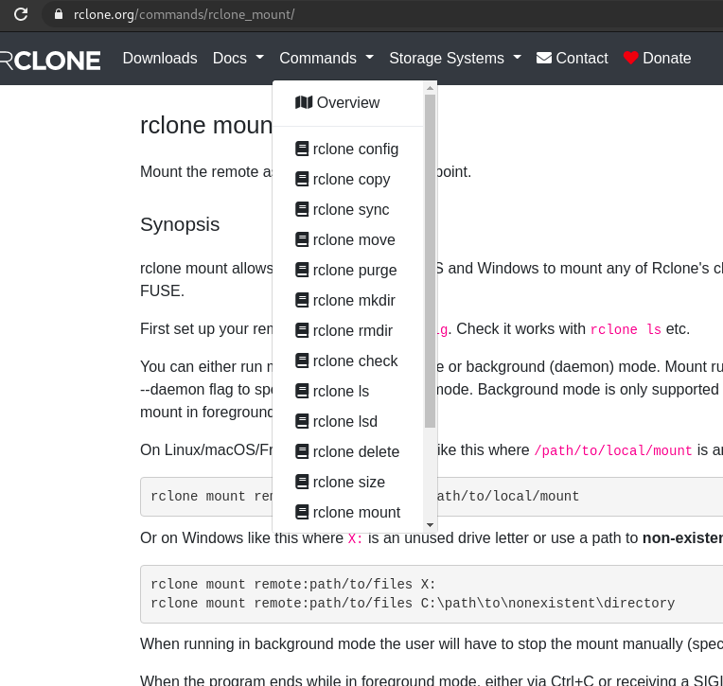

1.2 Just use Gnome:

Makes it so you can use your google drive through Nautalis. Very useful. But files are not copies locally, so it is not doing a backup.

<https://fedoramagazine.org/connect-your-google-drive-to-fedora-workstation/>

<https://linuxconfig.org/google-drive-on-ubuntu-18-04-bionic-beaver-linux>

the bottom of that link^ also leads into a description of ocamlfuse

.. this turns out to be super simple, just go to gnome settings->Online Accounts, and select Google and it shows up under Nautilus. However it complained that it does not support the hw key, and I had to work around that - every time I log in? Hmm.. Alas, Nautilus lists it as a 'network' and it does not appear to be mounted anywhere in the file system. There is just a bunch of seemingly random data under run/user/gvs/google…

1.3 ocamlfuse is often mentioned

looks like a remote mount for the the google drive

docs say that google docs sheets, etc. will be read only.

1.4 Google Drive ODrive Flatpak

docs says it can do everything needed. Ok so let's try this.

<https://www.odrive.com/> "sync all cloud data in one place" "free for 7 days" oops .. but the 'o' is for open … hmmm two different programs? versions?

Fedora specific:

<https://tutorialforlinux.com/how-to-install-google-drive-flatpak-on-fedora-gnu-linux-distro/>

Hi! The Tutorial Shows You Step-by-Step How to Install Google Drive Client ODrive Flatpak App in Fedora GNU/Linux Desktops.

Most noteworthy: with ODrive the Google Drive Documents are immediately Synced into Regular Folder instead of WebDav Clients like Gnome Online Account.

<https://tutorialforlinux.com/2020/04/21/step-by-step-google-drive-flatpak-fedora-31-installation/>

And ODrive is a Free, Open-Source Electron-based App ..

the tutorial promised at this site appears to be missing WIP? They point to

<https://flathub.org/apps/details/io.github.liberodark.OpenDrive> Which leads here:

<https://github.com/liberodark/ODrive/>

initial.md says: "Recommend to use VGrive as alternative of this app" ooookaaaay …

<https://github.com/bcedu/VGrive/>

can be installed with a snap on Ubuntu

<https://websiteforstudents.com/install-open-drive-google-drive-linux-client-on-ubuntu-18-04-16-04/>